# **ArchivesSpace Best Practices**

General ArchivesSpace Terms:

* Resource is a Collection
* Archival Object is any Series, subseries, folder, or item
* Top Container is a Box

# Arrangement Priorities

1. Only process to significantly improve access
2. Preserve original order if meaningful
3. If original order inhibits access and use, order by the records’ function
4. If records do not document functions, order with similar records
5. Make arrangement as simple an intuitive as possible

# Resource Level

### Basic Information

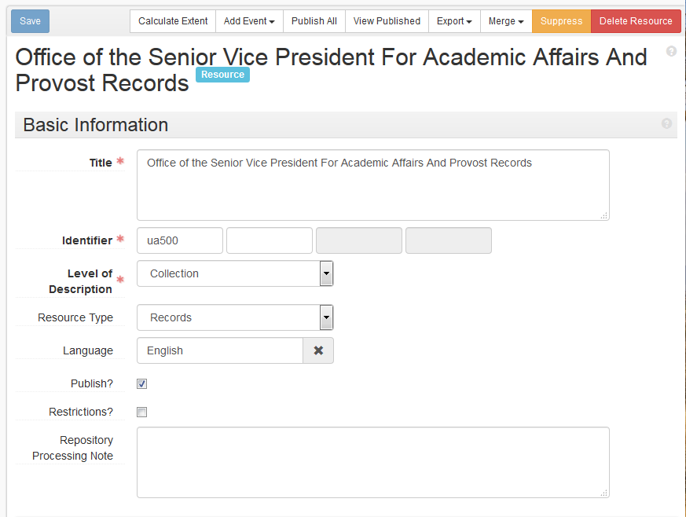

**Title:** Title will be provided or discussed with Jodi, Melissa, or Greg

**DACS:** (<https://github.com/saa-ts-dacs/dacs/blob/master/part_I/chapter_2/3_title.md>)

**Identifier:** Collection ID will be provided

**Level of Description**: All Resources are Collections

**Language:** English unless otherwise specified

**Publish?**: Do not publish Resource unless approved

**Restrictions?**: Check Restriction Checkbox if there are any restrictions within a collection

### Dates

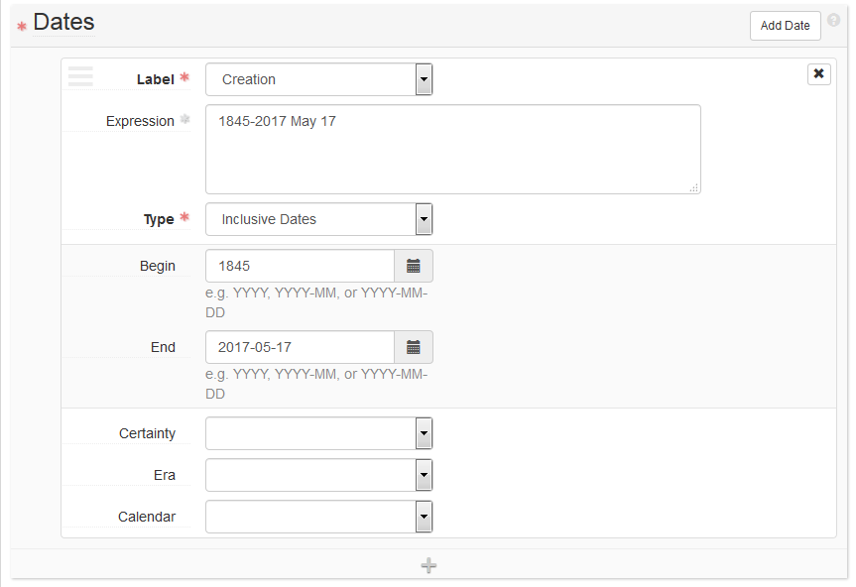

At least one date is always mandatory.

**Label:** Creation, unless otherwise specified

**Type:** Inclusive, unless otherwise specified, rarely a second bulk date is used.

**Begin/End**: Begin and End dates are the primary dates in ISO 8601 format

*Single Date Examples:*

Begin: 1993

Begin: 1996-02-08

Begin: 1955-10

*Inclusive Date Examples:*

Begin: 1977-04-15 End: 1978-12-25

Begin: 1993 End: 1994

Begin: 1884-03 End: 1884-04

**Expression**: Is additional date for display using DACS format

*Examples:*

Begin: 1996-02-08 Expression: 1996 February 8

Begin: 1902-08 Expression: 1902 August

Begin: 1977-04-15 End: 1978-12-25 Expression: 1977 April 15-1978 December 25

Begin: 1993 End: 1994 Expression: 1993-1994

Begin: 1884-03 End: 1884-04 Expression: 1884 March-April

Begin: 1985-06-17 End: 1985-06-20 Expression: 1985 June 17-20

### Extents

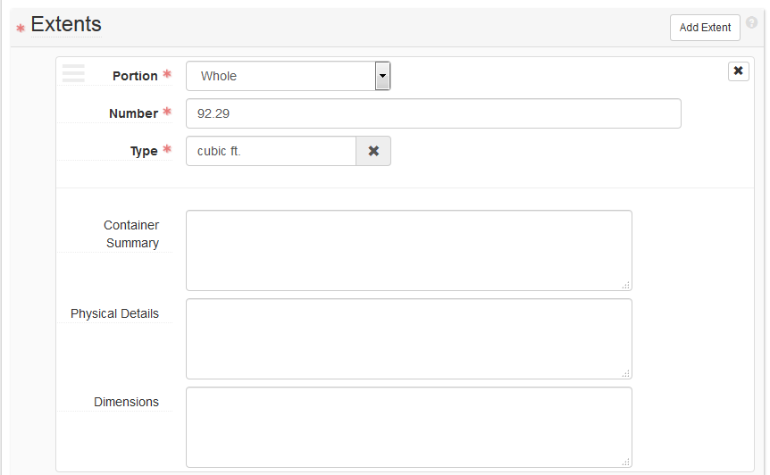

**DACS:**

*This element indicates the extent and the physical nature of the materials being described. This is handled in two parts, a number (quantity) and an expression of the extent or material type. The second part of the Extent Element may be either:*

* *the physical extent of the materials expressed either as the items, containers or carriers, or storage space occupied; or*
* *an enumeration of the material type(s), usually physical material type(s), to which the unit being described belongs. Material types may be general or specific.*

**How to Calculate Cubic ft.**

* Record in cubic feet using the following designations:
* Record center box – 1.0 cubic ft.
* ½ sized document or Hollinger box (letter) – .17 cubic. ft.
* Document or Hollinger box (letter) – 0.33 cubic. ft.
* ½ sized document or Hollinger box (legal) – 0.2 cubic. ft.
* Document or Hollinger box (legal) – 0.4 cubic. ft.
* 40 ½ X 18 X 10 flat folder – 4.2 cubic. ft.
* 30 ¼ X 18 ¼ X 6 ¼ flat folder – 2.0 cubic. ft.
* 25 X 21 X 3 ½ flat folder – 1.0 cubic. ft.
* 16 X 16 ¾ X 5 flat folder - 0.4 cubic. ft.
* 12 ½ X 9 ½ X 3 flat folder - 0.2 cubic. ft.
* 15 ½ X 10 ½ X 3 clamshell box - 0.3 cubic. ft.
* To calculate another size container in cubic feet, measure length X width X depth. There are 1728 cubic inches in a cubic foot so if measuring in inches, divide by 1728 to calculate cubic feet.

**Portion**: Whole unless otherwise instructed

**Number**: (remember leading 0)

**Type**: Typically “cubic ft.”

**Examples:**

* 13.5 cubic ft.
* 0.17 cubic ft.
* 33 Digital Objects

### Finding Aid Data

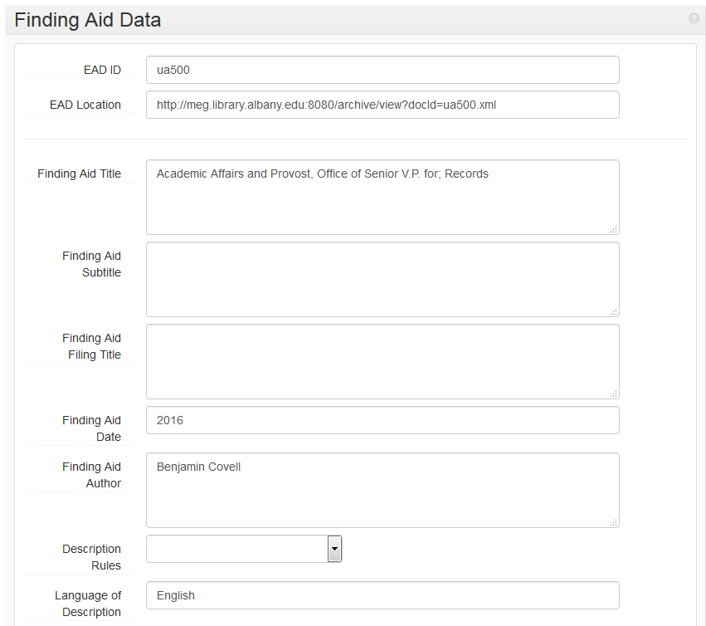

**Fields Used**

* **EAD ID** is the same as the collection identifier from Basic Information
* **Ignore EAD Location**
* **Finding Aid Title:** is collection title in filing order, then semicolon (;) and collection type
  + Capital Defender Office; Records
  + Crone, Michelle; Papers
  + English, Department of; Records
  + Eighth Step, The; Records
  + Campus Directories; Collection
* **Finding Aid Date**: Year of publication
* **Finding Aid Author:** Your name
* **Language of Description:** English

### Revision Statements

### 

* Add a revision whenever you do a significant alteration of description
* Use a DACS-style date
* Describe the change in a single sentence
* Include your name

### Related Accessions

* Linked accessions usually managed by Jodi, Melissa, or Greg
* Ignore unless otherwise specified

### Agent Links

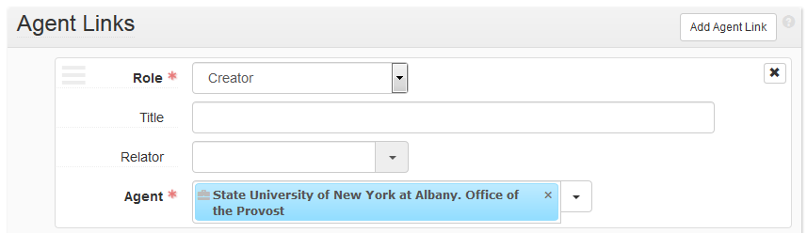

* A Creator is mandatory
* Subjects DO NOT go here

**DACS:**

*This element identifies the corporate bodies, persons, and families associated with the creation, assembly, accumulation, and/or maintenance and use of the materials being described so that they might be appropriately documented and used to create access points by which users can search for and retrieve descriptive records.*

### Subjects

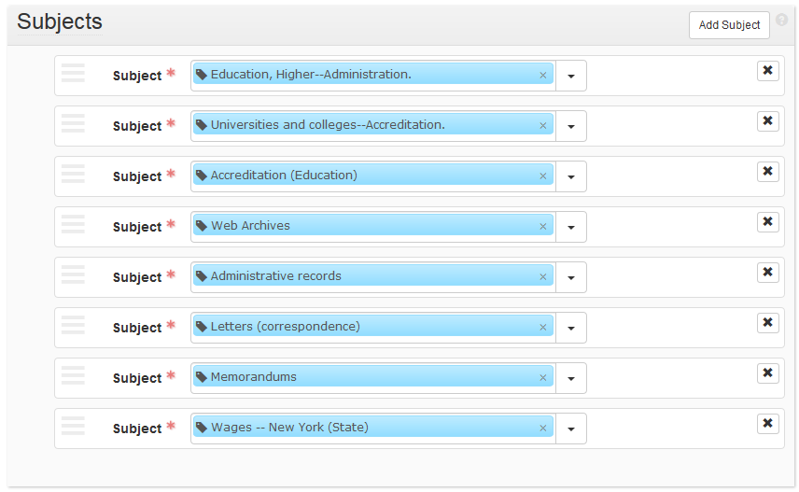

* Use the best handful of LCSH subject headings
* Use one or two relevent UAlbany-specific headings (<http://library.albany.edu/speccoll/findaids/eresources/static/subjects.html>)
* Use University Archives navigation headings as directed

## **Notes**

For all Notes:

* LeavePersistent ID blank, ArchivesSpace will create it
* Note order is irrelevant

### Abstract

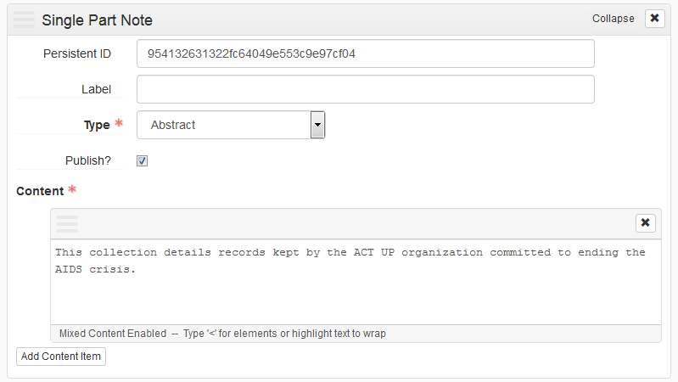

* A summary of the collection in a single sentence, if possible. Second sentence if necessary.
* Avoid XML tags
* Examples:

“The Atlantic States Legal Foundation Records document the environmental not-for-profit organization’s pollution reduction and environmental remediation projects and cases throughout the United States and territories.”

“Namesake of Pierce Hall, she served as Dean of Women from 1913-1933, supported the construction of dorms for women and aided the institutionalization of *in loco parentis*.”

“Contains materials used by Virginians for Alternatives to the Death Penalty (VADP) in its efforts to end capital punishment in Virginia.”

### Language of Materials

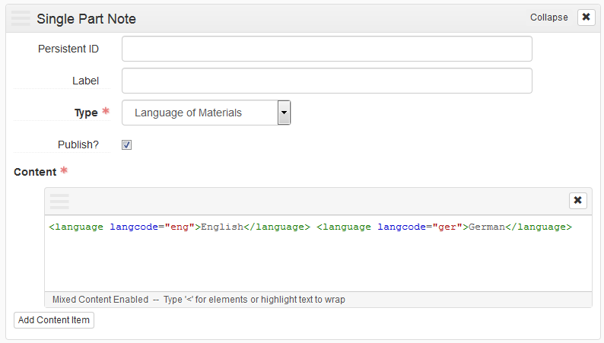

**DACS:**

*This element identifies the language(s), script(s), and symbol systems employed in the materials being described, particularly as they may affect its use.*

* For single language, just put “English” as the content
* Use XML with ISO 639-2 language codes for multiple languages
* Examples:

<language langcode="eng">English</language>

<language langcode="ger">German</language>

### Physical Location

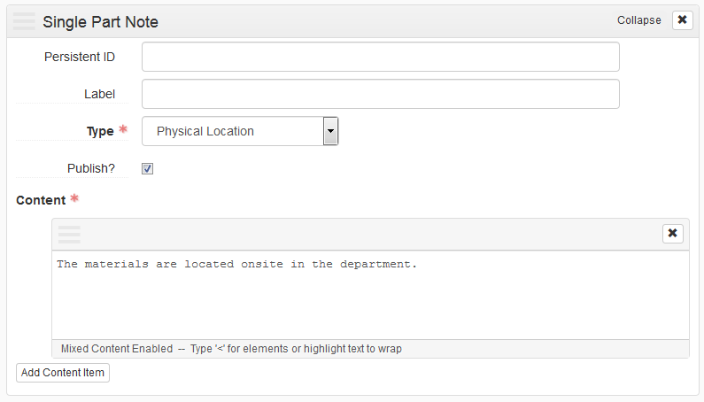

**DACS:**

*This element provides information about access restrictions due to any physical characteristics or storage locations that limit, restrict, delay, or otherwise affect access to the materials being described.*

* Unless otherwise directed, use “The materials are located onsite in the department.”

### Processing Information

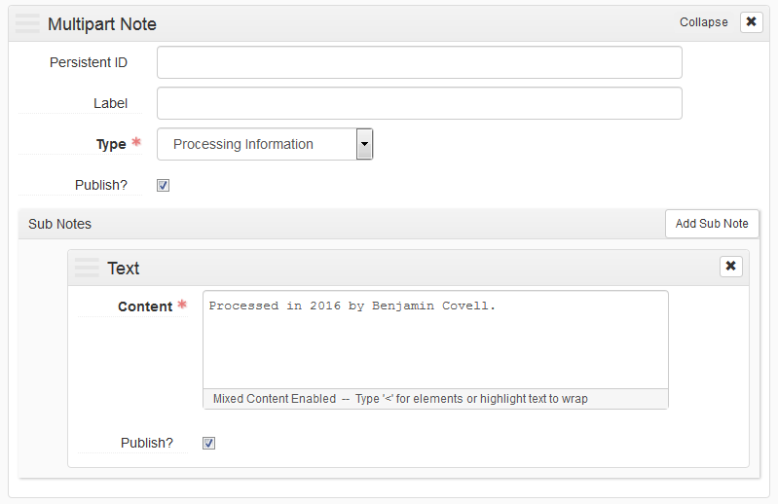

**DACS:**

*Record the name(s) of the person(s) who prepared or revised the authority record and any other information pertinent to its creation or maintenance.*

* Note that you processed the collection and when, and add any pertinent information on the impact of your work on the collection

### Historical Note (Biographical/Historical – Administrative History)

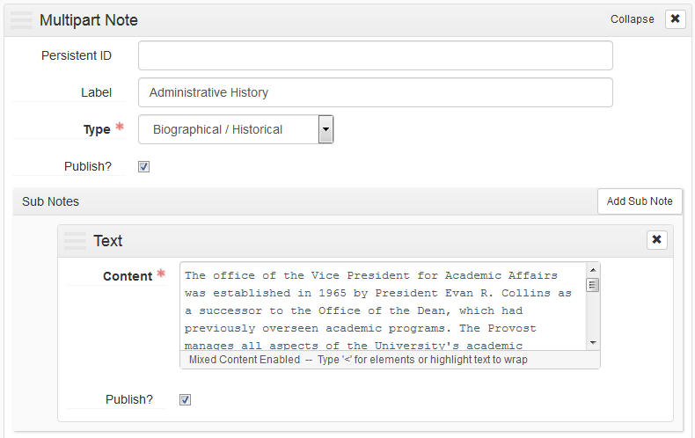

**DACS:**

*The purpose of this element is to describe the required elements of a biographical or administrative history note about creators embedded in the description of materials. The administrative/biographical history provides relevant information about corporate bodies, persons, or families who are identified using the Name of Creator(s) Element and who therefore function as nominal access points. This element also describes the relationship of creators to archival materials by providing information about the context in which those materials were created.*

(For Examples: <https://github.com/saa-ts-dacs/dacs/blob/master/part_I/chapter_2/7_administrative_biographical_history.md>)

* Generally use “Administrative History” for Corporate bodies, “Biographical Sketch” for people or families
* Don’t write too much, a paragraph or two will work
* Focus on providing relevant context of the records for researchers
* Ask Jodi, Greg, and Melissa for examples from relevant collections if needed

**Example:**

The office of the Vice President for Academic Affairs was established in 1965 by President Evan R. Collins as a successor to the Office of the Dean, which had previously overseen academic programs. The Provost manages all aspects of the University's academic mission. This includes oversight of all of the undergraduate and graduate programs, enrollment, and advisement. The Provost is also responsible for overseeing the registration process for new academic programs as well as the periodic review, conducted by the State Education Department and by outside accrediting bodies, of existing programs. As of 2016, the office is referred to as the Office of the Provost, while the Provost's title remains Senior Vice President for Academic Affairs and Provost.

### Scope and Content Note

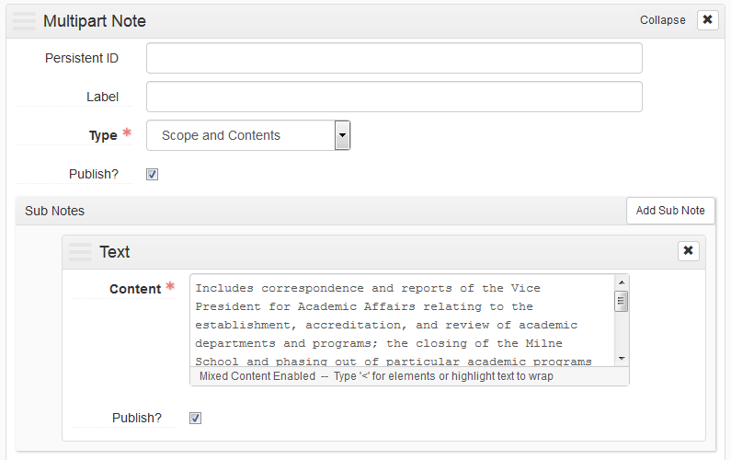

**DACS:**

*This element provides information about the nature of the materials and activities reflected in the unit being described to enable users to judge its potential relevance. The Scope and Content Element may include information about any or all of the following, as appropriate:*

* *The function(s), activity(ies), transaction(s), and process(es) that generated the materials being described*
* *The documentary form(s) or intellectual characteristics of the records being described (e.g., minutes, diaries, reports, watercolors, documentaries)*
* *The content dates, that is, the time period(s) covered by the intellectual content or subject of the unit being described*
* *Geographic area(s) and places to which the records pertain*
* *Subject matter to which the records pertain, such as topics, events, people, and organizations*
* *Any other information that assists the user in evaluating the relevance of the materials, such as completeness, changes in location, ownership and custody while still in the possession of the creator, and so on*

(<https://github.com/saa-ts-dacs/dacs/blob/master/part_I/chapter_3/1_scope_and_content.md>)

* This is the most important note, but still try to be brief while still effectively describing form and function of the records
* Form not format
  + A bank check can be written on a watermelon, it’s still a bank check
* Function, the purpose the record were created for and document
* In select instances, the scope note may also explain to researchers what is not included in the collection. For example, if you are describing the papers of an individual who served in both the New York State Assembly and New York State Senate, but we only have materials from the individual’s service in the Senate, use the scope note to state this.

**Example:**

Includes correspondence and reports of the Vice President for Academic Affairs relating to the establishment, accreditation, and review of academic departments and programs; the closing of the Milne School and phasing out of particular academic programs in the 1970s; administrative policies about probation, transfer students, enrollment and faculty salaries; long range planning documentation; documents on international programs; and campus construction and space planning documentation. Also included is a complete run of bulletins and course catalogs.

### Arrangement

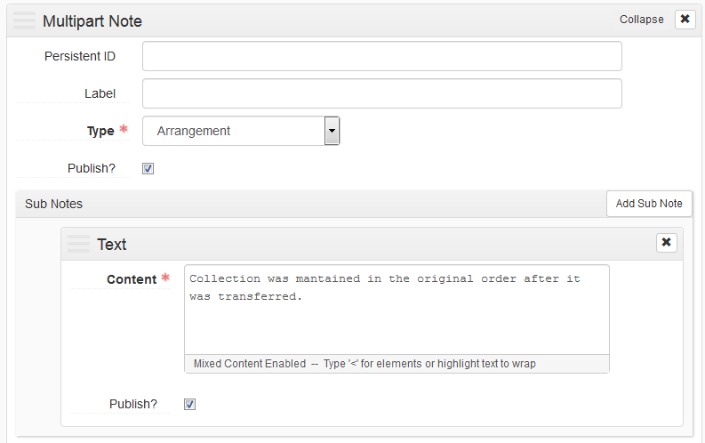

**DACS:**

*This element describes the current organization of the collection.*

* Will likely require more detail for manuscript collections than University Archives
* Describe any original order that was reclaimed or maintained
* “Collection was maintained in the original order after it was transferred.” may suffice
* For manuscript collections, this is a more common example of the detailed nature of this note: “The materials are arranged chronologically for each series except for Series 5: *O Albany!*, Series 14: Essays and Series 16: Correspondence, which are arranged alphabetically by subject.”

### Immediate Source of Acquisition

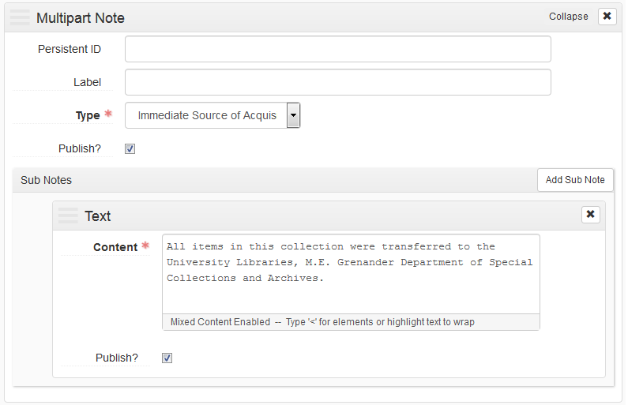

**DACS:**

*This element identifies the source from which the repository directly acquired the materials being described, as well as the date of acquisition, the method of acquisition, and other relevant information.*

* Ask Jodi, Greg, or Mellissa for information from the collection file
* Minimal: “All items in this collection were transferred to the University Libraries, M.E. Grenander Department of Special Collections and Archives.”
* Hopefully add at least the source and the date.

**Examples:**

Michelle Crone donated all items in this manuscript group to the University Libraries, M.E. Grenander Department of Special Collections and Archives, from 2001 to 2004.

These records were transferred to the M.E. Grenander Department of Special Collections & Archives, University Libraries, University at Albany, by the University Senate. Paper records are transferred prior to 2014, and likely prior to 2001. Since 2016, records are created, managed, and maintained only in digital form. Most records since the early 2000s were born-digital and managed by Elisa Lopez, secretary in the President's Office. After 2016 these records are automatically transferred to the archives periodically as they are created.

### Conditions Governing Access

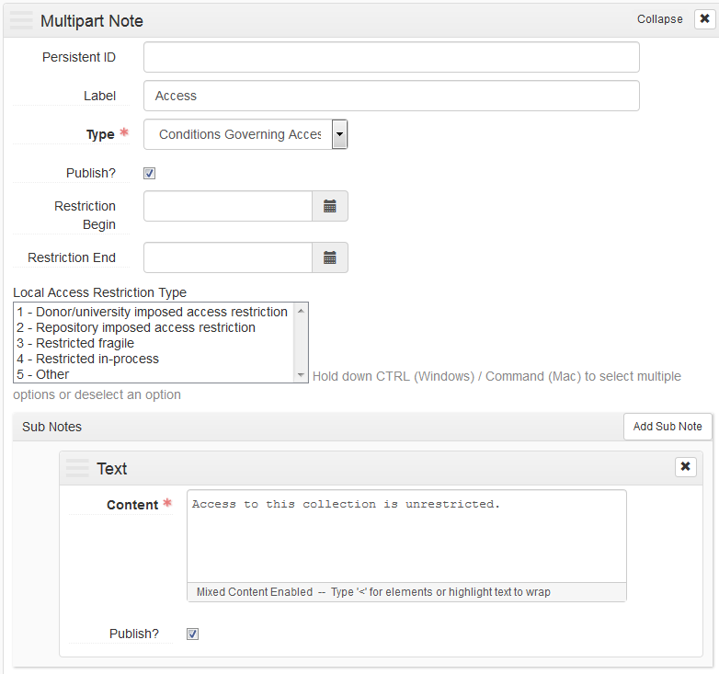

**DACS:**

*This element provides information about access restrictions due to the nature of the information in the materials being described, such as those imposed by the donor, by the repository, or by statutory/regulatory requirements.*

* Default: "Access to this collection is unrestricted.**”**
* Use “Access” as the Label
* Jodi, Greg, or Melissa will tell use if there are conditions governing access to include

### Conditions Governing Use

### 

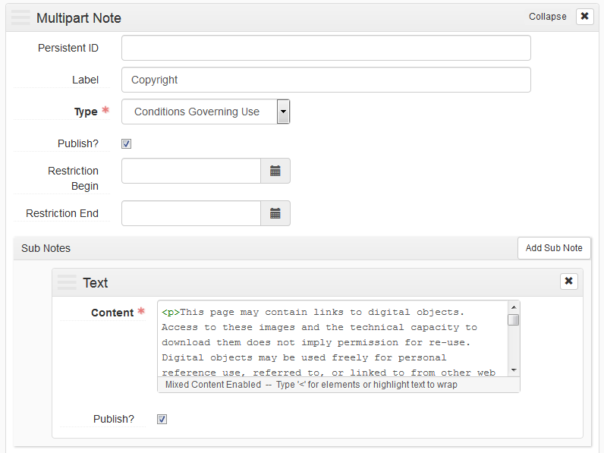

**DACS:**

*This element identifies any restrictions on reproduction due to copyright or other reasons, as well as restrictions on further use of the materials being described, such as publication, after access has been provided.*

Unless otherwise specified, use:

<p>This page may contain links to digital objects. Access to these images and the technical capacity to download them does not imply permission for re-use. Digital objects may be used freely for personal reference use, referred to, or linked to from other web sites.</p>

<p>Researchers do not have permission to publish or disseminate material from these collections without permission from an archivist and/or the copyright holder.</p>

<p>The researcher assumes full responsibility for conforming to the laws of copyright. Some materials in these collections may be protected by the U.S. Copyright Law (Title 17, U.S.C.) and/or by the copyright or neighboring-rights laws of other nations. More information about U.S. Copyright is provided by the Copyright Office. Additionally, re-use may be restricted by terms of University Libraries gift or purchase agreements, donor restrictions, privacy and publicity rights, licensing and trademarks.</p>

<p>The M.E. Grenander Department of Special Collection and Archives is eager to hear from any copyright owners who are not properly identified so that appropriate information may be provided in the future.</p>

### Preferred Citation

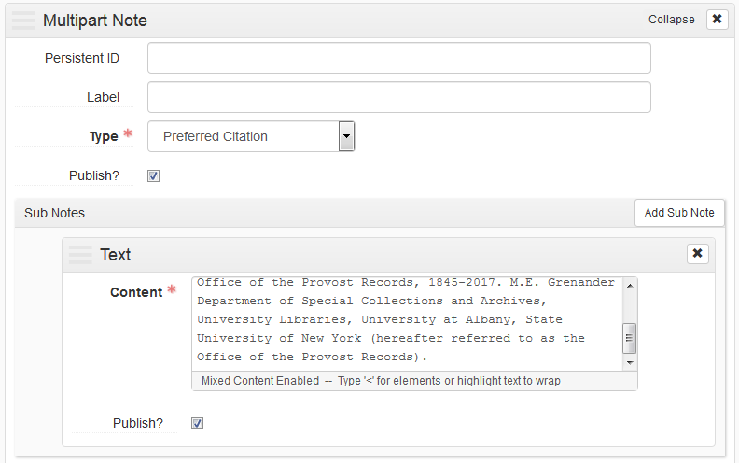

**Alter this template, change collection, dates, and shortened name:**

Preferred citation for this material is as follows: Identification of specific item, series, box, folder, **Michelle Crone Papers**, **1927-2000**. M.E. Grenander Department of Special Collections and Archives, University Libraries, University at Albany, State University of New York (hereafter referred to as the **Crone Papers**).

# Archival Objects Level (not linked to instances)

Generally series or subseries. Anything not linked to a container. May not be necessary if collection has no series.

* Notes cascade, only add additional notes when they add more detail that upper levels
* Same description rule apply at all levels
* Generally need:
  + Title
  + Date
  + Extent
  + Scope and content
  + For manuscript collections, include arrangement

# Archival Objects Level (linked to instances)

Typically folders or items. Anything linked to a container

* Not all collections will have detailed inventories at the folder level
* Notes cascade, only add additional notes when they add more detail than upper levels
* Same description rule apply at all levels
* Generally need:
  + Title
  + Date
  + Link to container with link to location
* Any more than a few records can be created or updated with the asInventory Spreadsheet

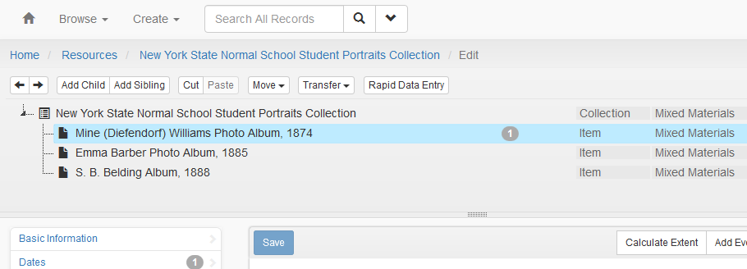

* Child and sibling records are added in edit mode to the collection tree
  + Records can be rearranged
  + Be careful!
* Enter only basic description: Title, Level, and Date(s)

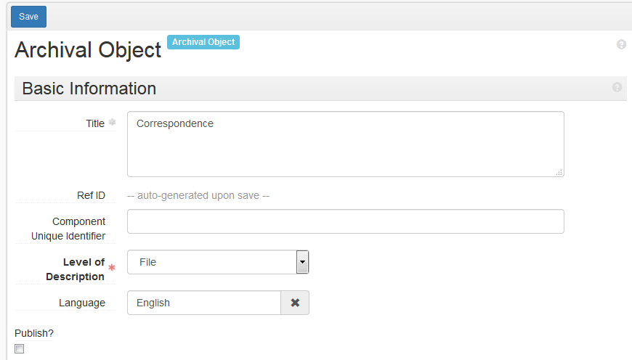

* Add a container in the Instances section near the bottom

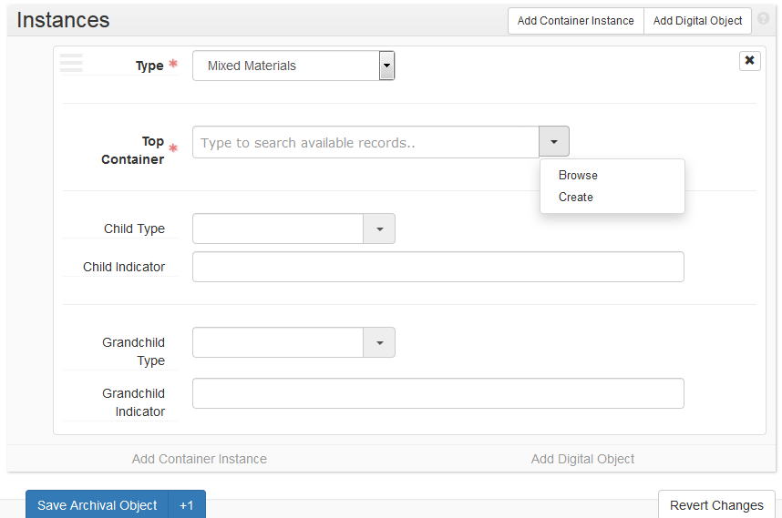

* Browse for an existing Top Container, or create a new one
* Container type is always mixed materials
* Container profile is blank
* Container Type is “Box” unless otherwise specified
* Indicator is the Box number

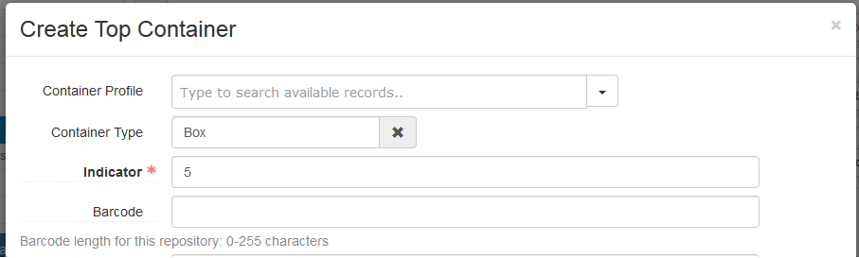

* Add a location
* Never make a new location
* Status is Current and Start Date is the default today
* Search by shelf coordinates, like “F 3 5 2”
* If you cannot find a location, ask Jodi, Melissa, or Greg

